**Business problem and who would be interested in this project.**

To find the best location for the business is very important. Investors may spend millions of dollars in a store. In this project, I will use New York as an example of how to find the best location of a business. Since there are 137 coffee shops, I will use coffee shops for this project. I am going to decide where would be the best location to open a new coffee shop in N.Y.

**Data**

The data will be gotten from Foursquare and I will use the GPS locations of the data to determine the best new coffee shop location

**Methodology**

1. I got the gps location of New York
2. I found out all the neighborhood of New York
3. I found out all business information and GPS data of the big neighborhood of NewYork using Foursquare
4. I applied the concept of KNN neighbor, but the further distance from the current existing coffee shops is the better this time. Inverse relation of the distance is applied in the algorithm

**Result**

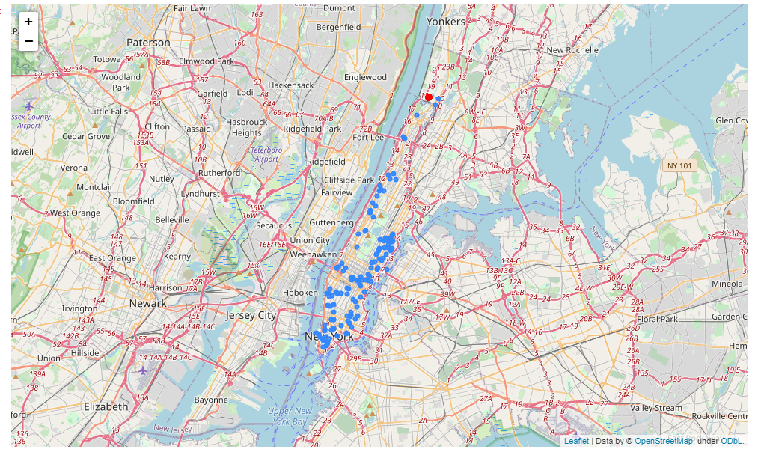

The blue dots are the current coffee shops locations. The red dot is the suggested location for the new coffee shop.

**Discussion**

The suggested location is very good because there is the least competitor.

**Conclusion**

In this project, Foursquare data and machine learning concept are applied to find the best location for a new coffee shop location.